





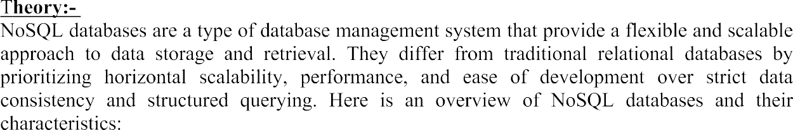





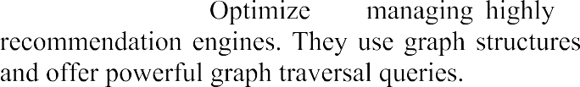

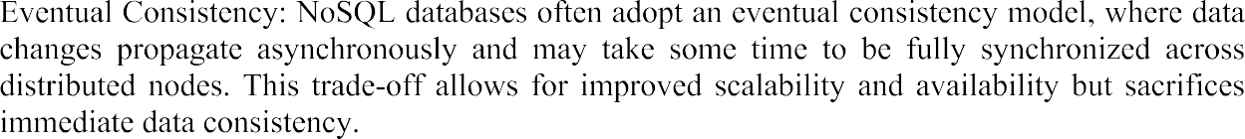

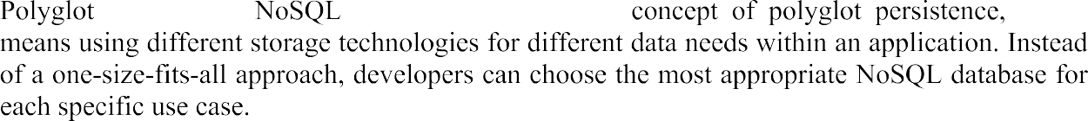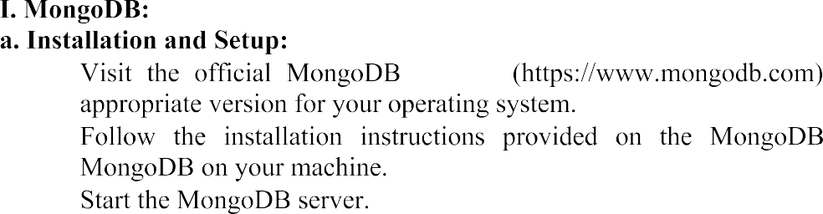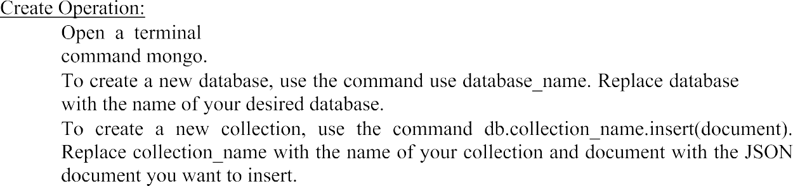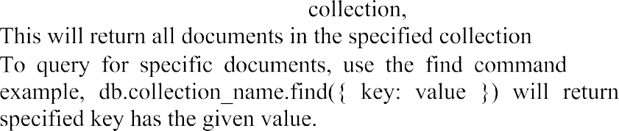

 

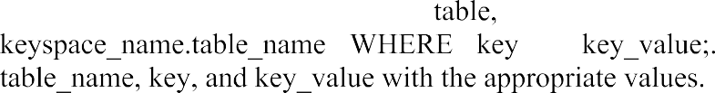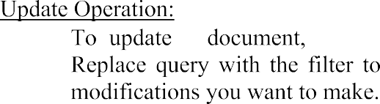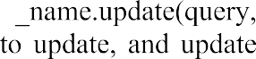



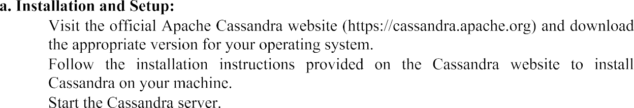



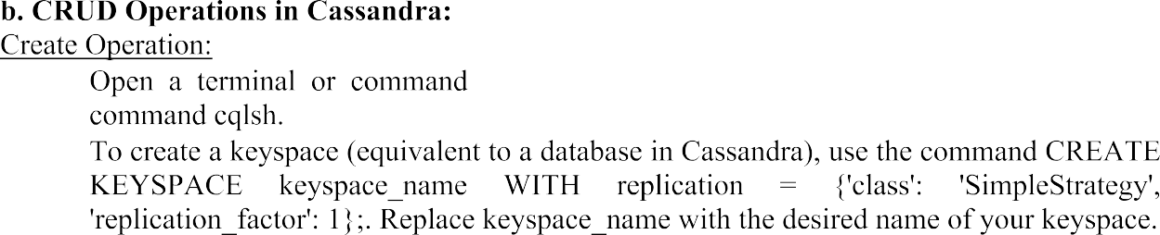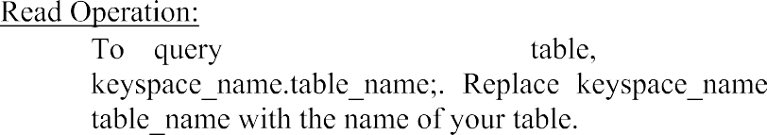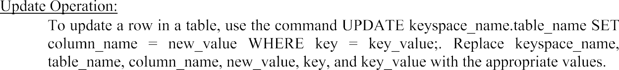

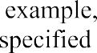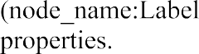 

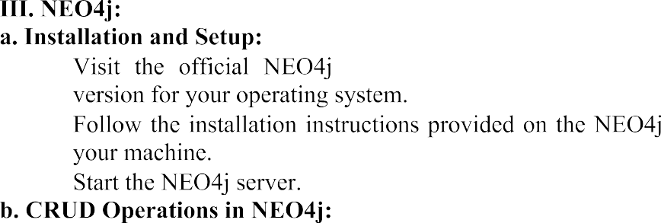



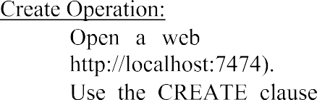

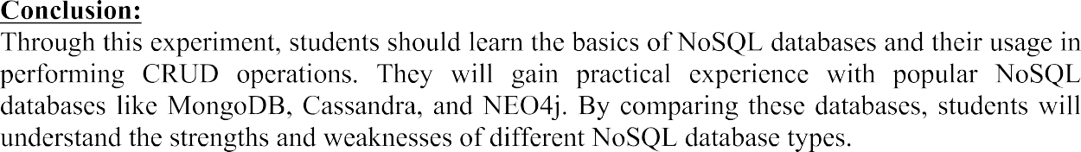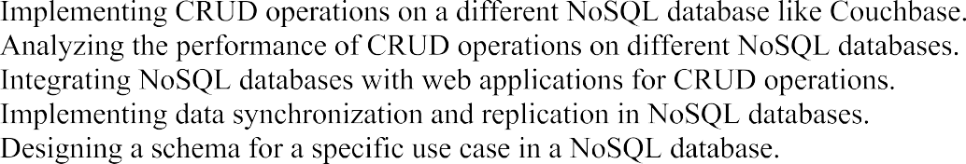

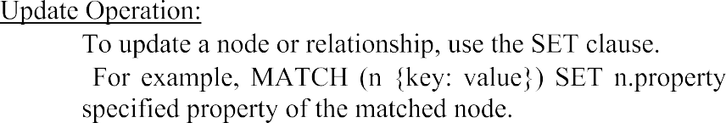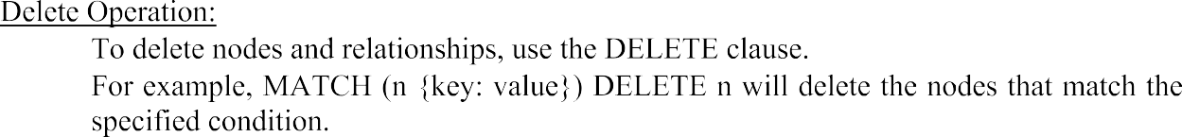



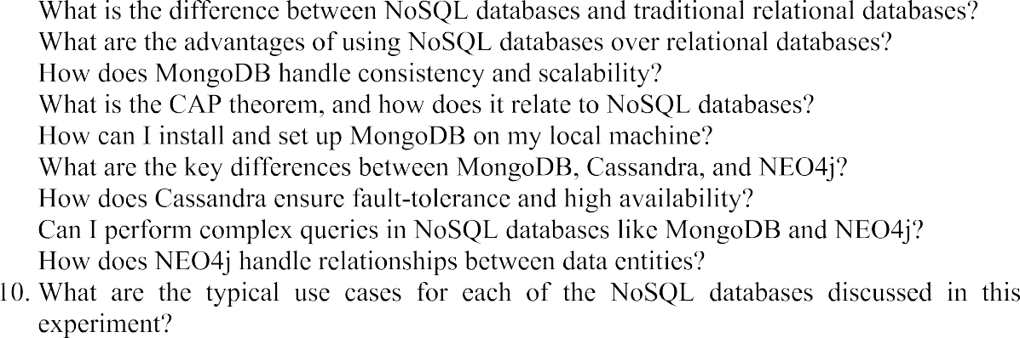

**Create Database in MongoDB:**

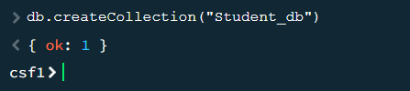

**Insert value into Database:**

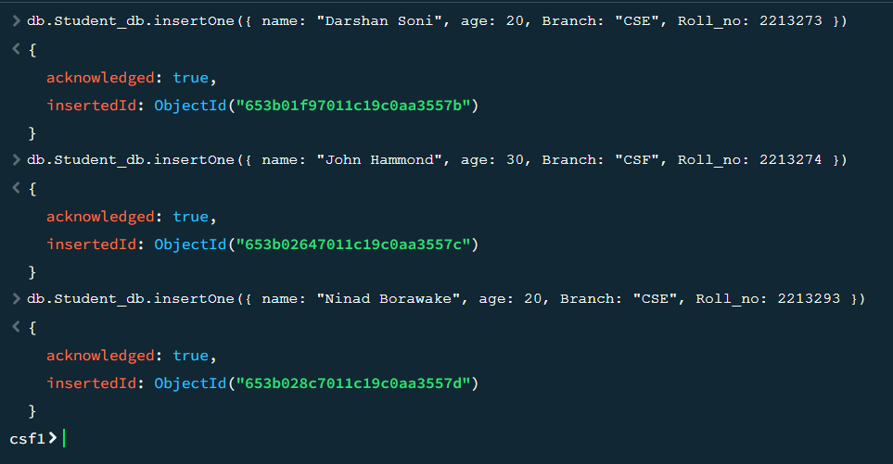

**Read Data from Database:**

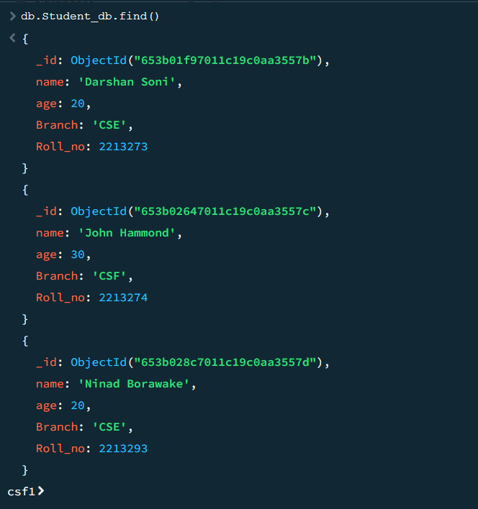

**Delete Data from the Database:**

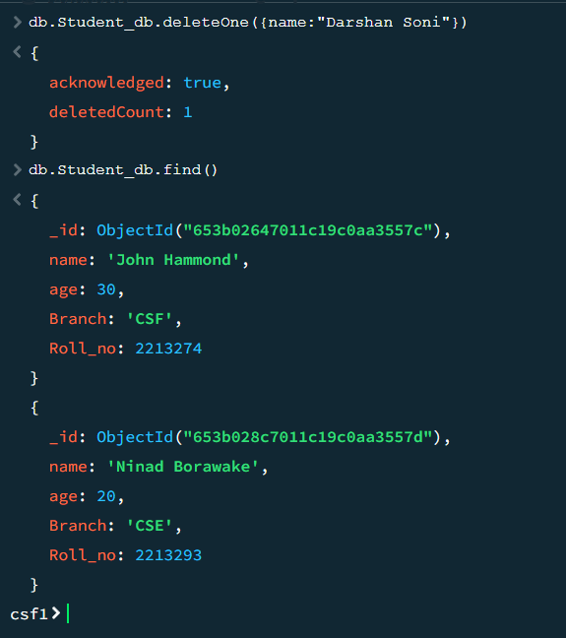

**Update Data from the Database:**

